18. **DATA ANALYSIS BY DENSITY BASED CLUSTERING ALGORITHM USING WEKA.**

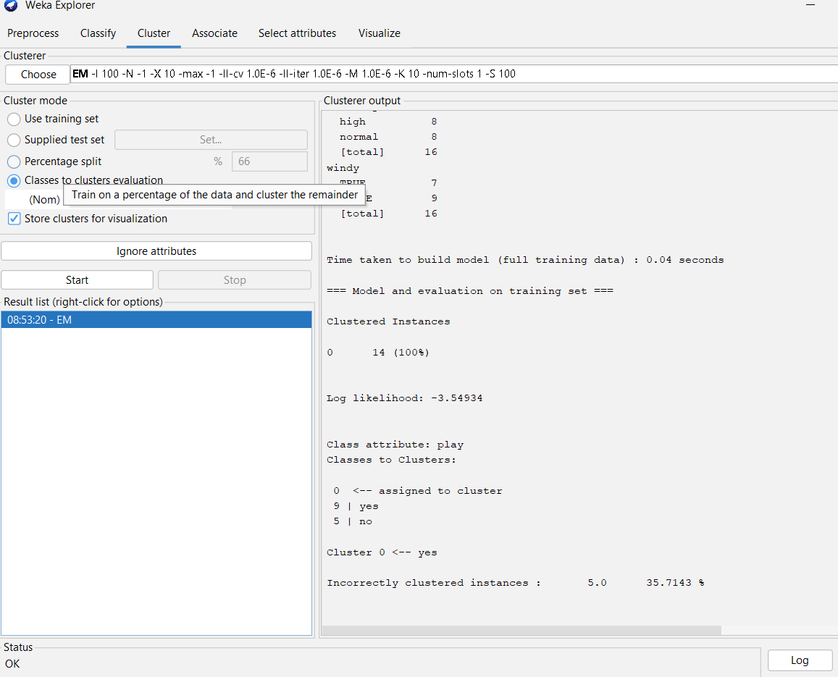

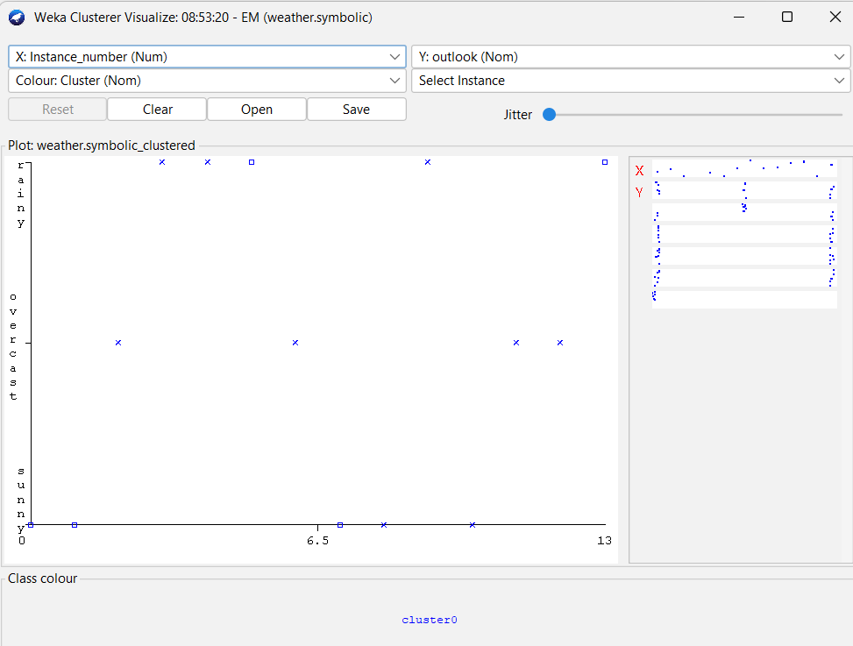

Output information…